ASHISH SINGH
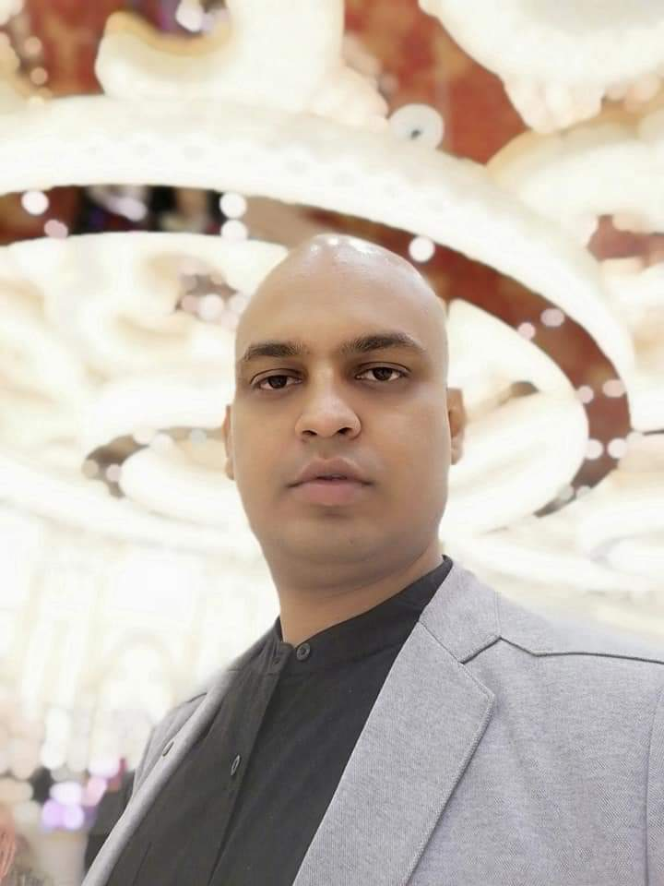

Contacts: 7234888878,9696766888
E-Mail: ashishsingh198486@gmail.com

CAREER OBJECTIVE

To Work in an environment which offer me opportunities to prove my capabilities and
Add to the growth of the Organization ; where I can prove my critical skills and knowledge.

CORE COMPENTENCIES

- Over 10 years extensive experience in sales planning, implementation and control in a leadership role and in an industrial sales function.
- Sales & Marketing activities across India handling corporate sales.
- Proven track record of meeting and exceeding sales targets.
- New Market Penetration, New product launches
- Result oriented, effective communicator, customer focused, commercial attitude, business acumen, analysis and critical thinking.
- Excellent analytical, negotiation & interpersonal skills with a reputation for building productive
Relationships at all levels with clients and partners.

CAREER HIGHLIGHTS

Currently Working with Century Plyboards (India) Limited from 1st Nov 2018 to till date as Sr. Area Sales Manger (Sales & Distribution).
( Territory under control - Noida ,G.Noida, Ghaziabad, Entire West U.P & Entire Uttarakhand)



The Company
Established in Kolkata,today centuryply is india’s leading plywood brand with consolidated operation across the country & outside the country. Building on 30years of industry experience and trust .Over the 30 years ,centuryply ,the pioneer in plywood manufacturing has now become india,s; brand offering the best in wood furnishing solutions.

Key Responsibilities
<Refine overall brand positioning, USP and create brand guideline, promote and enhance the brand.
<Prepare market research and competitor analysis with continual updates.
< Define targets markets and develop applicable pricing models.
< Channel expansion & Demand Generation.
<Achieve targets set by the company in relation Marketing Budget Spend,& design relevant marketing and sales strategy
<Create marketing and PR strategy for pre launch and post launch era consistent with the overall Business strategy.

Worked with Hawinks Cooker Ltd as Area Sales Manager (Sales & Distribution) from 1st April 2015 to 30th Oct 2018



The Company
Hawkins Cookers Limited is an Indian company, based in Mumbai and manufactures pressure cookers and cookware, The company has three manufacturing plants at Thane, Hoshiarpur and Jaunpur. It manufactures under brand names of Hawkins, Futura, Contura, Hevibase, Big Boy and Ventura.

Key Responsibilities
<To ensure the profitability of the unit through customer satisfaction.
< Arrangement of legal support to the required unit
< Hands on experience in understanding the needs of the prospective customer and provide them with Suitable solution .
< To ensure prompt service to the customer
< To provide Event Management , Training and support to the unit concern



Worked with Pidlite Industries as Senior Business Development Executive from
July – 2009 to March 2014 .( Joined as BDE and promoted to Sr.BDE)

The Company

Pidilite is a consumer centric company committed to quality and innovation. For decades, we have been pioneering products for small to large applications, at home and industry, which have forged strong bonds with people from all walks of life.
From adhesives, sealants, waterproofing solutions and construction chemicals to arts & crafts, industrial resins, polymers and more, our product portfolio is as diverse as it is ever-evolving. Today, our brands are trusted household and industrial names, and we are the market leader in adhesives.
A robust and growing network makes our products accessible across demographics and geographies.
We also embrace our responsibility towards the community through social initiatives in rural development, education and healthcare.

Key Responsibilities

<Dealing with the corporate as well as Retail customer & handling their quires Building public relation a customer interaction to generate the new customer
<To maintain the continuous follow up.
<Providing product training to Sales team to get better output.

ACADEMIC CREDENTIALS

- M.B.A./PGDBM (Major- Marketing, Minor – Finance) from BLS Institute of Management, Delhi approved by AICTE, Ministry of HRD (Govt. of India) .(2007-2009) [1st Div]
- Completed B.Com from S.S.N College( Delhi University)(1nd Div)[2003-2006]
- Passed 10+2 under C.B.S.E, from St ACS (1st Div..),Varanasi[2003]
- Passed 10 under C.B.S.E, from St ACS (1st Div..), Varanasi[2001]
.

IT SKILLS and Areas of INTEREST

IT SKILLS : General Operability skills which include tools and software for daily work.
Knowledge in MS Excel & MS office ,Window (xp, Home, proff, Linux), Html, Sql (Basic).

AREAS OF INTEREST : Customer Relationship ,Brand Management and Marketing Research , Risk and Investment Management, Event Management

PERSONAL ATTRIBUTES / STRENGTHS

- Good Interpersonal skills, Networking and persuasiveness.
- Logical, analytical thinking base.
- Love to take time bound challenges and always strive for excellence
- Ability to work in demanding situations and good at multitasking.
- Good team management and leadership skills.

PERSONAL SYNOPSIS

Date of Birth : 05 – 07 – 1984
Father’s Name : Mr.Ram Sunder Singh
Martial Status : Married
Current Address : Plot no -38, 1st floor ,Vaishali ,sector-5
behind ,Shoprix Mall , Ghaziabad -201010
Current CTC :12.5 Lakh p.a plusVariable plus Sales Incentive
Expected : Negotiable

